Project: Cloudy Day
Difficulty: Level 1

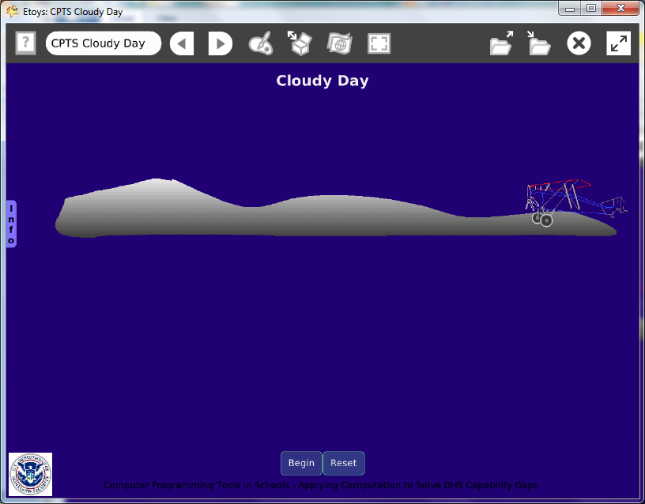

Time: Four 45 minute labs

Challenge:
Make a project that uses Morse Code to conceal a message. Include reference web sites as clues to solve the puzzle.

Programming:
There are four scripts, one moves the cloud, one moves the plane and the other two use scripting tiles to begin and reset the action.

Things you’ll need to know:
Quick Guides
- Paint Tools/ All
- Halo Handles/All
- Supplies: Text, Add a New Flap
- Object Catalog: Digital Images, Polygon
- Script Tiles: X and Y Tiles, Exact Location, Hide and Show, Tests Category
- Menus: Normal Ticking, Button Fires a Script, Bring to Front

Things to think about:
- Morse Code could be dots and dashes, colors, sounds, or shapes.
- If the project is enjoyable on one level will it conceal its real message?

Extensions:
- What is steganography?
- Would this project be more challenging if a second or even a third message was concealed using different shapes in a less obvious way?
- Hide the message so that the code shows when the airplane above each part. Should the part stay visible or hide immediately after the plane moves away from it?
- Use the sound effects, such as clink and croak, or the sound category tiles to send a Morse Code message.

NETS for Students:
http://www.iste.org/standards/nets-for-students/nets-student-standards-2007.aspx
1. Creativity and Innovation: a, b
2. Communication and Collaboration: a
3. Research and Information Fluency: b, c
4. Critical Thinking, Problem Solving, and Decision Making: a, c
5. Digital Citizenship: a
6. Technology Operations and Concepts: a, b, c, d

CSTA:
CSTA Level II: Objectives and Outline
http://csta.acm.org/Curriculum/sub/CurrFiles/L2-Objectives-and-Outlines.pdf
Level II objectives for middle school students are furthered through studying a programming language well enough that the student is proficient with it. Whether the language is Etoys, StarLogo TNG, or Scratch, it is the ability to use the language to express ideas that is valuable. A student skillful enough to use any programming language to express ideas, solve problems, model behaviors, simulate data, or to educate or entertain is an entitled person in today’s society.
Topics of particular note are:
Topic 2: Problem Solving
Topic 6: Connections between Mathematics and Computer Science
Topic 11: Programming Languages
Topic 13: Multimedia

Common Core Standards Mathematics:
http://www.corestandards.org/the-standards/mathematics
6. NS.6, 6. EE.2

Teacher Notes:
Materials: Provide a chart with Morse Code to encode messages. The whole text can be encoded; this example just encodes the word that is revealed as the cloud and airplane move across the screen.

These are useful reference sites:
http://morsecode.scphillips.com/alphabet.html

http://www.bckelk.ukfsn.org/menu.html

http://www.learnmorsecode.com/

www.cit.umich.edu/u/provos/stego

http://www.jjtc.com/pub/r2026.pdf
Exploring Steganography: Seeing the Unseen
"Steganography is an ancient art of hiding information. Digital technology gives us new ways to apply steganographic techniques, including one of the most intriguing— that of hiding information in digital images."

Comments: Objects - Scripts – Decisions
Give students time to learn a little Morse Code and to think about how it could be concealed. They will need time to imagine where they will conceal the Morse Code in the project painting or text.
The scripts in this example project do not take much time to make but more complicated and subtle ideas will take more time to script. Give students time to try projects made by others for this assignment.

Example Scripts:

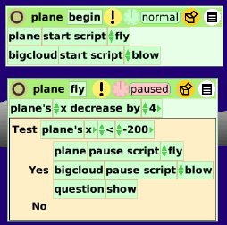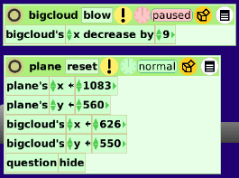

The sketch of the airplace was traced from a photo at:

Student Notes:
Security through obscurity is not as safe as security through design.

http://morsecode.scphillips.com/alphabet.html

http://www.bckelk.ukfsn.org/menu.html

http://www.learnmorsecode.com/

www.cit.umich.edu/u/provos/stego

http://www.jjtc.com/pub/r2026.pdf
Exploring Steganography: Seeing the Unseen

